Improved Guide: Deploy Sophos Endpoint via ITSupport247 (ConnectWise Automate)
Author: Luis Lazo
Collaborators: George Udosen (Teacher), Perplexity AI
Date: Feb 15, 2026
Purpose: Silently push Sophos Central Endpoint to Windows devices per customer tenant using PowerShell in ITSupport247 (ConnectWise Automate CC/Asio).​
Prerequisites
- Sophos Central Partner access.
- ITSupport247 login (user.itsupport247.net).
- Test on 1-2 clean VMs first (no existing AV).​
- Run as Local System (default in Automate).
Step-by-Step Instructions
- Get Tenant-Specific Installer Link
  - Login: central.sophos.com > My Products > Partner Portal.
  - My Business > Customers
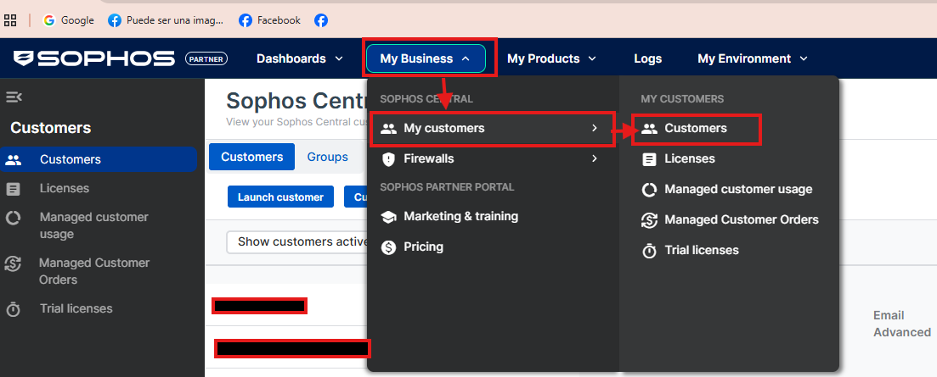
  - Select Customer>Launch customer
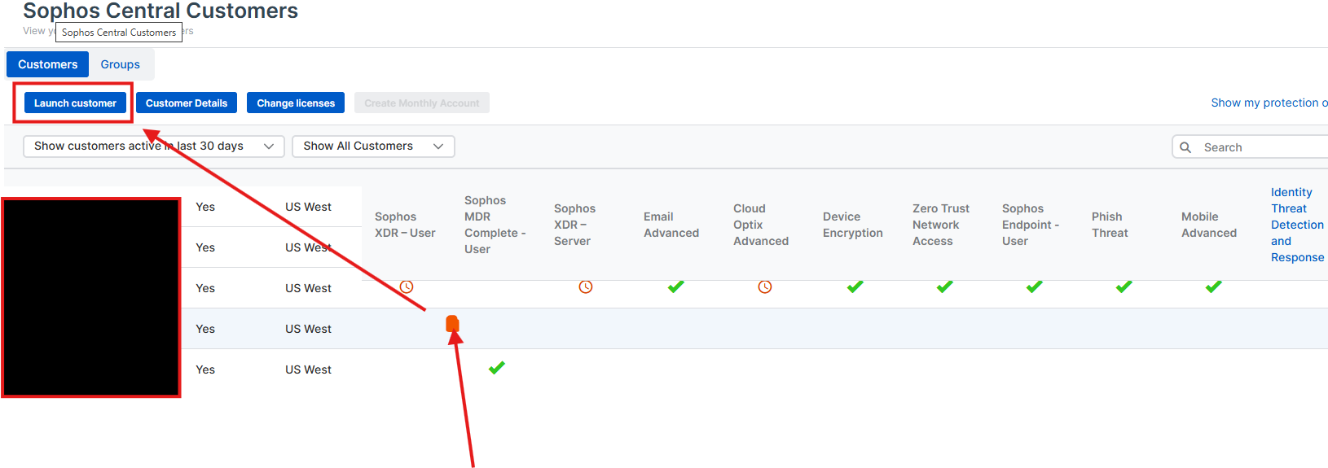
  - My Products > Endpoint Protection > Installers.
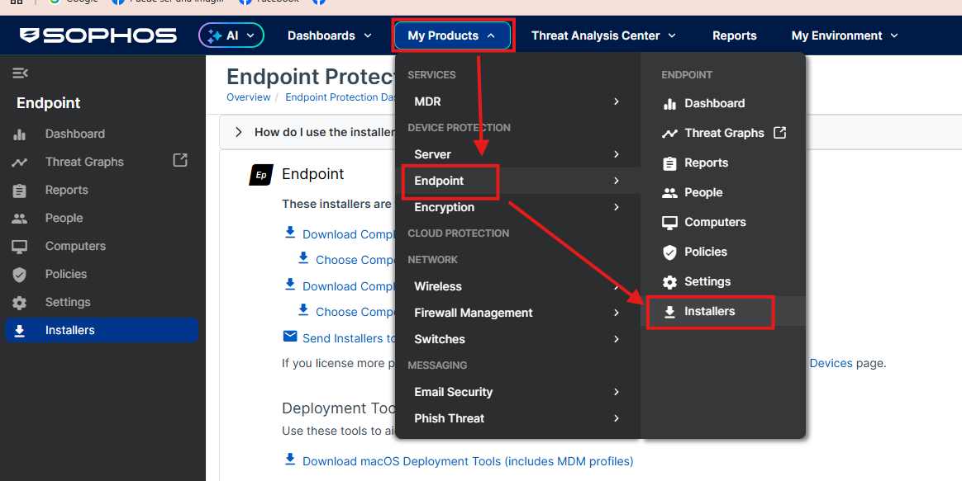
  - Right-click Download Complete Windows Installer > Copy link address.
Unique per tenant; expires ~30 days—regen if fails.​
Example: https://dzr-api-amzn-us-west-2-fa88/XXXXX/SophosSetup.exe
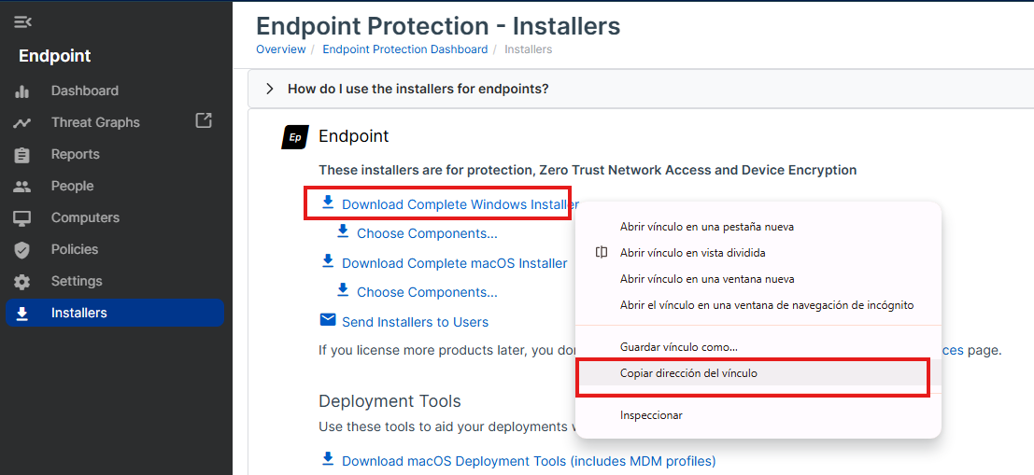
- Login to ITSupport247 (ConnectWise Automate)
  - Go to user.itsupport247.net > Connect Asio (or Automation dashboard).
  - Navigate: Automation > Scripts > New > PowerShell Script.
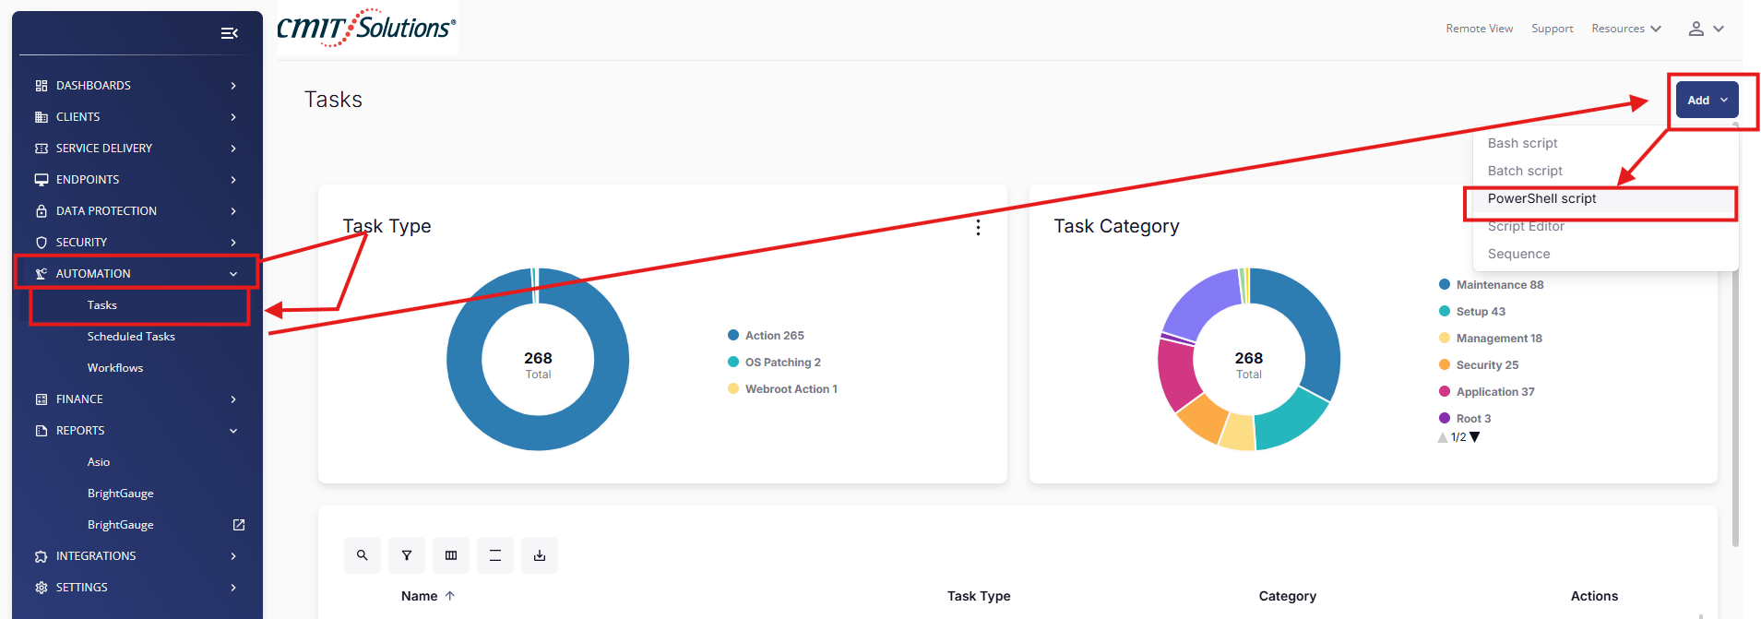
- Create & Customize Script
  - Name: Sophos Endpoint Install - [Customer Name]
  - Category: Application (for inventory tracking).
  - Language: PowerShell.
  - Paste this robust script (replace $SophosUrl with Step 1 link):
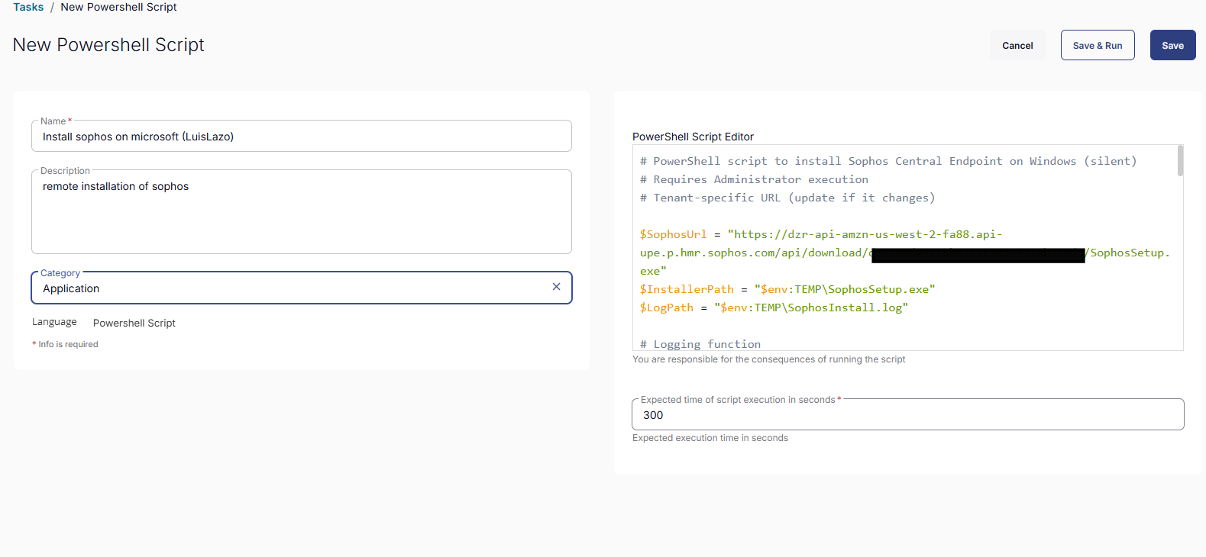
powershell
# [Your improved script from earlier here – silent install w/ log/verify/reboot prompt]
$SOPHOS_URL = "PASTE_LINK_HERE"
# ... (full script as provided previously)
- Run As: Local System.
- Timeout: 900s (15min).
- Save > Test Run on single agent.​
- Deploy & Schedule
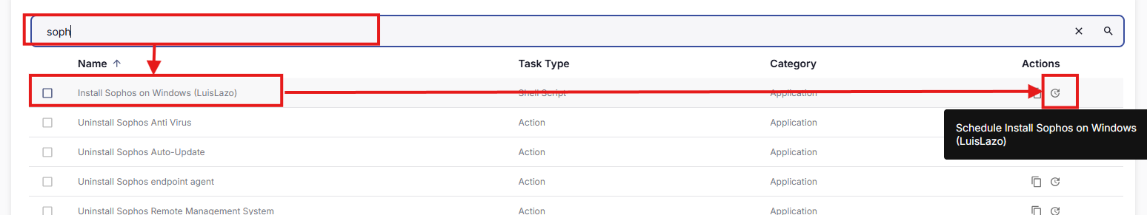
  - Targets: Select client/group (test 1st).
  - Run Now or Schedule (e.g., off-hours).
  - Monitor: Agent > Scripts tab > Logs (%ProgramData%\ConnectWise\Logs).​

